**Summary for Prohorseracetips - Competition page**

We want to remake a page on an existing website.

Please check

<http://prohorseracetips.com.au/tipping-competition.php>



This page(the part we can see under “Weekly Competition”) is the only page developed by third party team, and it is now being managed by them.

So we want to make our own page similar current one but a bit simpler.

Once again, we will just work for the page under “Weekly Competition”.

Here is the test account to check the page.

user: phrttest

password: phrttest

You need to enter the user name in the text box saying Enter Tipping ID and tap “LOGIN” button on the right.

When you logged in you can see following screen.

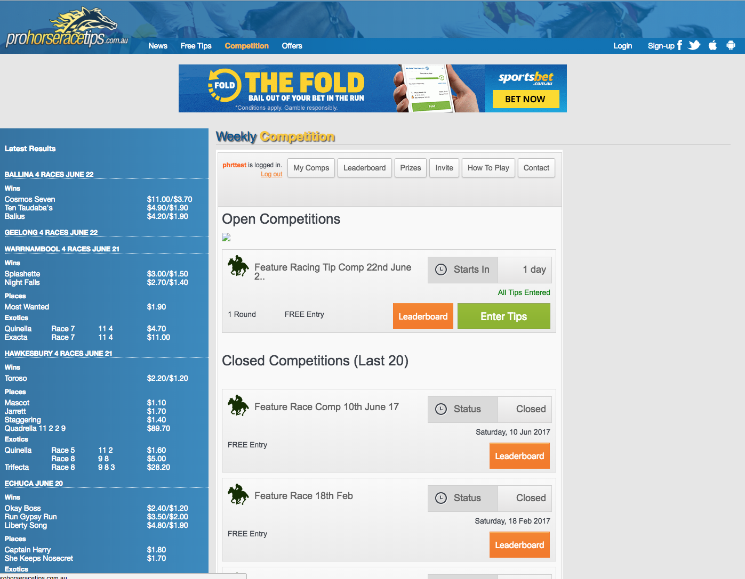

As you can see, users can enter tips for open competition and get prize after the competition is over according to the race results.

**In new system we won’t have payment system - we will just have save and show results. (Prizes would be managed by outer system)**

Users can start entering their tips starting from Wednesday.

This is when the race fields are announced, so users will have from Wednesday, until Saturday to enter their tips.

Then after the races, they have a leaderboard to see who did the best, those who do the best win prize.

To get better understand how to play this, please check “How To Play” tab.

So from sometime Wednesday or Thursday every week, you will see how users can enter their tips. Here are such pages you can see when there is open competition.

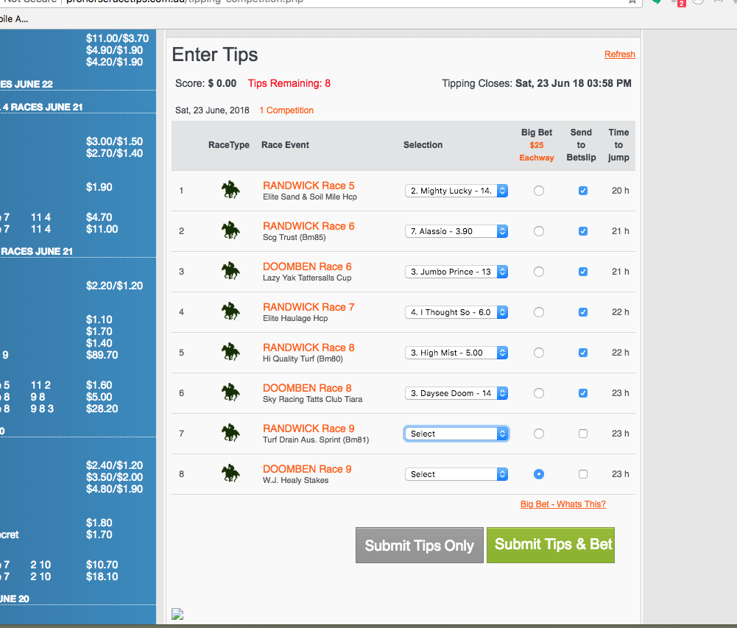

This page shows how you enter tips on open competition.

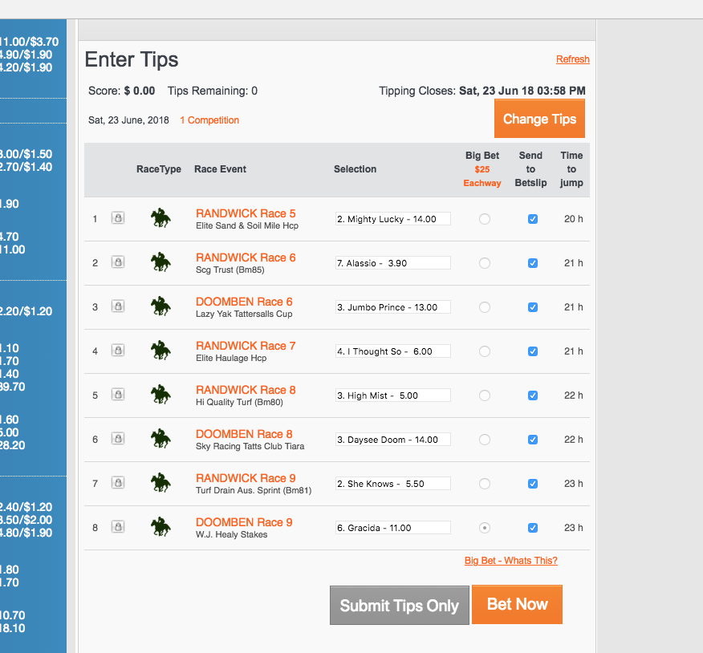

When you’ve already submit the tips, you will see this page.

Here you can change tips until the first race begins.

When the competition is over on Saturday, users can see the result of all tips in the Leaderboard.

I hope you to check all functions in current page to clear understand.

**Main flow and details for new system**

**1. The manager will upload csv files to server with the horses and races information before the competition is open.**

The manager(we don’t need to code it) will download the csv files from third party system and upload them to the server.

So we can just check if there are new csv files and use them.

Here are the csv files.

For horses:

<https://www.dropbox.com/s/4g8pmr3gyarhj1q/CAU20180630H-2.csv?dl=0>

For races:

<https://www.dropbox.com/s/4by78exqj3m87ft/CAU20180630R.csv?dl=0>

1.1. We will have admin page specially to upload races, horses and races result info.

There would be buttons to upload the csv files, so that we can check the files and save data to db when the files are uploaded.

1.2. The race result file would have following format.

<https://www.dropbox.com/s/sx9lbq0yhre8rc5/CAU20180630H_Result.csv?dl=0>

(We can add some columns if we need some more information.)

**2. Users would enter tips based on the races and horses info until the first race begin.**

A competition will have about 8 races that run one by one for 2-3 min.

We need to save the tips on server db or other type of storage.

Requirments here:

2.1. When users try to enter tips for the first time, users will be asked to fill out a small form of username, email, sportsbet ID.

In current system, we have the tables to check them. (Please ignore this)

We will have new table for account management for new system.

So when the user sign up, we will add a new row to new table.

2.1.1. We will need sign in as well to login to new system. The user can enter username or email to sign in.

You can detect the format of the entered text and check if there is same username or email.

2.2. And there will need to be a message “Only Sportsbet members can enter this comp”

2.3. “New users can join here” link will be provided. (It will direct to a certain page)

2.4. And “Cash Prizes given for top tipster” would be needed as well.

2.5. We need to design table in current db and implement the module for users to enter tips as the following screen.



2.6. We don’t need any payment function here.

In current system there is a Prizes tab/button where you can check your prizes and you can claim the prizes with payment.

In new system we don’t need this tab and its function.

2.7. Some details on the page we submit tips. (Enter Tips)

In new system we need similar tips entering page as current one except for some difference.

2.7.1. We can submit or resubmit(change) the tips until 5 minutes before the first race.

After that, we can’t change or submit tips for the competition.

So we can get the “Tipping Closes” time as “first race start time - 5 minutes”

2.7.2. We don’t need “Big Bet” options and “Send to Betslip” check boxes in new system.

We have removed those features for simplicity.

2.7.3. We will use just “Win only” mode on tipping and score calculation at the end.

In current system uses 10$ Eachway on every tip, but we will change it as “Win only” mode.

To get the clear image about this, you can refer 4.

2.7.4. When you select a horse as predicted winner for each each, you can see its weight for the horse. The weight will come from the horse csv file as odds column(we will say it as odds from now). It will be considered as a “weight” on final score calculation.

You can see the odds on current horse csv file. Please note the odds value would change after the competition is over. So you can get new odds in race result csv file and use it for final score calculation.

2.7.5. We will have only “Submit Tips Only” button at the bottom here.

So we will remove “Submit Tips & Bet” button and its function.

2.7.6. When you submit tips, tips should be entered for all races.

And we have only one open competition in a week.

2.7.7. Other details

Once you’ve success in submission, you will see “submitted notify” and following screen.

We need same features as current one except for Big Bet options, Send to Betslip check boxes, Bet Now button.



We will have variable number of races in a competition. It ranges from 7 to 11.

**3. The manager will upload csv files of race results to the server after the competition is over.**

We can discuss the structure of the csv files for race results later. I don’t think it will be complex at all.

**4. We need to calculate scores of each users(who entered tips) based on the tips data and race results, and store and show them in the way that current system does.**

To describe the calculation details, I will take a example of a close competition. (When you tap “My Comps” button, you will see open competitions and closed competitions.)

On a closed competition, you can open the leaderboard for the competition to see calculation result.

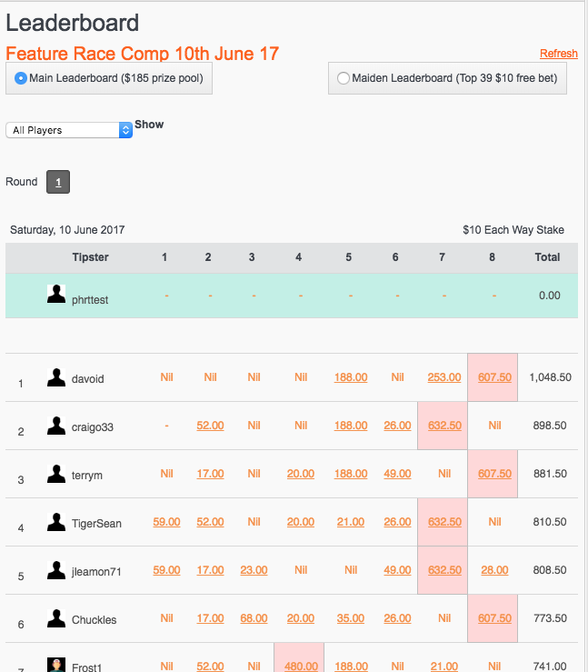

When you tap a underlined score(Let’s see 188.00 on the first row.), you will see details dialog for that score as following.

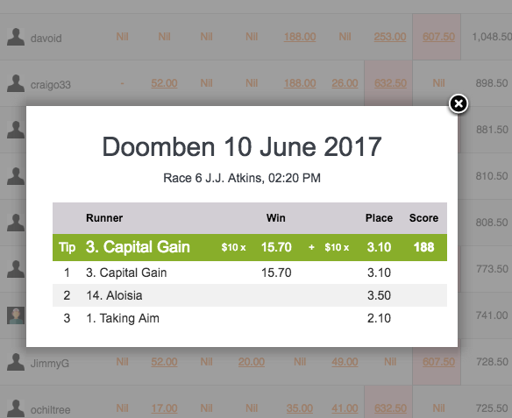

Top green colored row shows the tip that the user chosen. And rest 3 rows shows winner, 2nd, and 3rd runner in the race.

And the numbers on the Win and Place columns shows the weight for score calculation when the horse is in “Win” or “Place”.

“Place” means that the horse finishes the race at 2nd or 3rd, while “Win” means that the horse finishes the race at the 1st.

In current system applies just $10 eachway to calculate the score.

Let’s see above case.

As the No. 3 horse wins and the user tipped it as the winner, we calculate the score as 10*15.7+10*3.1=188.

If we assume that the user tipped No. 1 (Taking Aim), we will calculate the score as 10*0+10*2.1=21. We can see 21.00 on the TigerSean’s row and on 6th column because the user(TigerSean) tipped Taking Aim at the race.

That is the how “eachway” is working.

The “win only” mode only consider “Win” weight. It does not consider “Placed” horses.

So on above case, the user will get the score as 10*15.7 = 157.

And if we assume that the user tipped Taking Aim, he will get 0.

Unlike the current system, we will give the prize to only the 1st tipster in a competition. The prize amount could change. (For example $100)

On the live leaderboard on the first page that we see sign up or log in, the current system shows W, P, L, M columns with ranking, username, total prize. In new system, we need only ranking, username, W(wins), total prize.

**Note - You should read it to work on**

**1. We need to make the new page mobile friendly as well.**

99% of users use Mobile to enter tips, so we will need to be mobile friendly as well.

**2. The page should have a good performance and simple & good looking.**

As you can see, current system’s performance is not so fast.

The new system should work better and looks better.

**3. We just need “My Comps”, “Leaderboard” and “How To Play” tabs/buttons and their functions on top menu.**

To make the system simpler in current version, we don’t include other tabs and their functions.

**4. I need all other functions in current system if we didn’t confirmed that we don’t need it.**

So if you are curious of some function, please ask me and confirm if we need it or not.

**5. We need to have complete source code and db structure step by step.**

We will progress each step by checking live page and source code and db structure.